HTMLEditor控件是一个全功能的富文本编辑器。除了基本编辑功能外，它还支持以下特性：
- 文本格式，包括粗体、斜体、下划线等等
- 段落设置，比如格式、字体、字号
- 前景和背景颜色
- 文本缩进
- 圆点和数字列表
- 文本对齐
- 添加水平标尺
- 复制和粘贴文本块
Figure 19-1 是一个JavaFX应用中的富文本编辑器。
Figure 19-1 HTML Editor
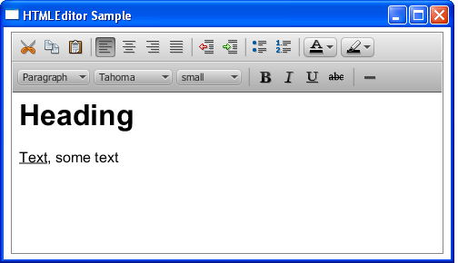
Description of "Figure 19-1 HTML Editor"
HTMLEditor 类呈现编辑内容使用的是HTML字符串形式，比如说，Figure 19-1 中的内容呈现以下字符串："<html><head></head><body contenteditable="true"><h1>Heading</h1><div><u>Text</u>, some text</div></body></html> ."
由于HTMLEditor 类继承了Node 类，所以可以为它的实例应用视效和转换。

添加HTML Editor
和其他UI控件一样， HTMLEditor组件必须加入场景才能在应用中显示。可以像 Example 19-1 这样直接添加，或者通过布局容器。
Example 19-1 Adding an HTML Editor to a JavaFX Application
import javafx.application.Application; import javafx.scene.Scene; import javafx.scene.web.HTMLEditor; import javafx.stage.Stage; public class HTMLEditorSample extends Application { @Override public void start(Stage stage) { stage.setTitle("HTMLEditor Sample"); stage.setWidth(400); stage.setHeight(300); final HTMLEditor htmlEditor = new HTMLEditor(); htmlEditor.setPrefHeight(245); Scene scene = new Scene(htmlEditor); stage.setScene(scene); stage.show(); } public static void main(String[] args) { launch(args); } }
编译运行上面的代码效果是 Figure 19-2 .
Figure 19-2 Initial View of the HTMLEditor Component
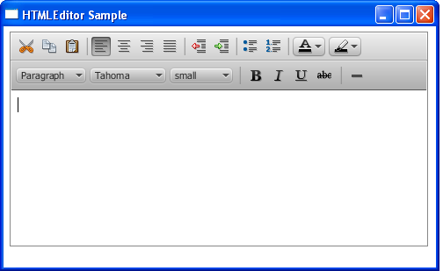
Description of "Figure 19-2 Initial View of the HTMLEditor Component"
实现该组件后就有格式栏，不能关闭它们。不过也可以使用CSS来改变其外观。见Example 19-2 .
Example 19-2 Styling the HTMLEditor
htmlEditor.setStyle( "-fx-font: 12 cambria;" + "-fx-border-color: brown; " + "-fx-border-style: dotted;" + "-fx-border-width: 2;" );
把它们加入到 Example 19-1 ，效果是Figure 19-3 .
Figure 19-3 Alternative View of the HTMLEditor Component
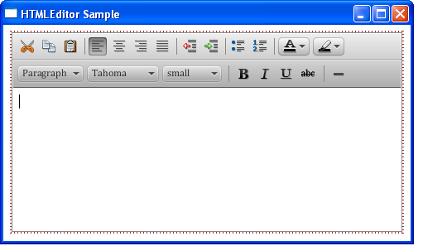
Description of "Figure 19-3 Alternative View of the HTMLEditor Component"
现在组件的边框和格式栏的字体改变了。
HTMLEditor 类提供了一个方法来定义应用启动后编辑区显示的内容。使用setHtmlText 方法来设置编辑器的初始文本，见Example 19-3。
Example 19-3 Setting the Text Content
private final String INITIAL_TEXT = "<html><body>Lorem ipsum dolor sit " + "amet, consectetur adipiscing elit. Nam tortor felis, pulvinar " + "in scelerisque cursus, pulvinar at ante. Nulla consequat" + "congue lectus in sodales. Nullam eu est a felis ornare " + "bibendum et nec tellus. Vivamus non metus tempus augue auctor " + "ornare. Duis pulvinar justo ac purus adipiscing pulvinar. " + "Integer congue faucibus dapibus. Integer id nisl ut elit " + "aliquam sagittis gravida eu dolor. Etiam sit amet ipsum " + "sem.</body></html>"; htmlEditor.setHtmlText(INITIAL_TEXT);
Figure 19-4 是使用setHTMLText 方法后的编辑器。

Figure 19-4 HTMLEditor with the Predefined Text Content
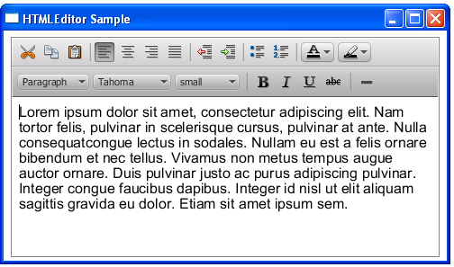
Description of "Figure 19-4 HTMLEditor with the Predefined Text Content"

可以在字符串中使用HTML标签来指定初始显示的文本格式。

用HTML Editor构建用户接口
能够使用 HTMLEditor 控件来实现典型的用户接口，比如说可以实现消息服务、email客户端、甚至内容管理系统。
下面实现一个消息排版窗口，在很多email客户端应用中都可以找到它。

Example 19-4 HTMLEditor Added to the Email Client UI
import javafx.application.Application; import javafx.collections.FXCollections; import javafx.geometry.Insets; import javafx.geometry.Pos; import javafx.scene.Group; import javafx.scene.Scene; import javafx.scene.control.*; import javafx.scene.layout.GridPane; import javafx.scene.layout.VBox; import javafx.scene.web.HTMLEditor; import javafx.stage.Stage; public class HTMLEditorSample extends Application { @Override public void start(Stage stage) { stage.setTitle("Message Composing"); stage.setWidth(500); stage.setHeight(500); Scene scene = new Scene(new Group()); final VBox root = new VBox(); root.setPadding(new Insets(8, 8, 8, 8)); root.setSpacing(5); root.setAlignment(Pos.BOTTOM_LEFT); final GridPane grid = new GridPane(); grid.setVgap(5); grid.setHgap(10); final ChoiceBox sendTo = new ChoiceBox(FXCollections.observableArrayList( "To:", "Cc:", "Bcc:") ); sendTo.setPrefWidth(100); GridPane.setConstraints(sendTo, 0, 0); grid.getChildren().add(sendTo); final TextField tbTo = new TextField(); tbTo.setPrefWidth(400); GridPane.setConstraints(tbTo, 1, 0); grid.getChildren().add(tbTo); final Label subjectLabel = new Label("Subject:"); GridPane.setConstraints(subjectLabel, 0, 1); grid.getChildren().add(subjectLabel); final TextField tbSubject = new TextField(); tbTo.setPrefWidth(400); GridPane.setConstraints(tbSubject, 1, 1); grid.getChildren().add(tbSubject); root.getChildren().add(grid); final HTMLEditor htmlEditor = new HTMLEditor(); htmlEditor.setPrefHeight(370); root.getChildren().addAll(htmlEditor, new Button("Send")); final Label htmlLabel = new Label(); htmlLabel.setWrapText(true); scene.setRoot(root); stage.setScene(scene); stage.show(); } public static void main(String[] args) { launch(args); } }

该接口包括一个选项框来选择接受类型，2个文本框来输入email地址和主题，一个标签来显示主题字段，一个编辑器，还有发送按钮。
使用Grid 和VBox布局容器把这些UI控件加入到应用的场景中。编译运行的效果见 Figure 19-5 ，这是一个用户正在排版周报。

Figure 19-5 Email Client User Interface
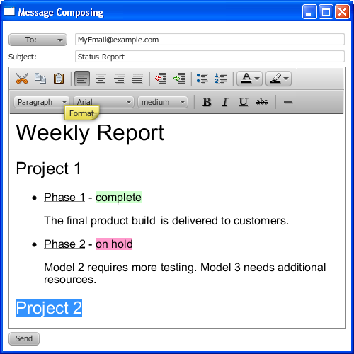
Description of "Figure 19-5 Email Client User Interface"

调用setPrefWidth 或 setPrefHeight方法为 HTMLEditor对象设置宽或高 ，当然根本不指定也行。Example 19-4 中为组件高度指定了值，而宽度由VBox悲剧容器控制了。当内容文本超出了编辑区的宽度和高度时，垂直滚动条就显示出来。

获取HTML内容
用JavaFXHTMLEditor控件，你可以编辑和设置初始内容。此外，你还可以以HTML格式获得输入的和编辑的内容。具体实现见Example 19-5

Example 19-5 Retrieving HTML Code
import javafx.application.Application; import javafx.event.ActionEvent; import javafx.event.EventHandler; import javafx.geometry.Insets; import javafx.geometry.Pos; import javafx.scene.Group; import javafx.scene.Scene; import javafx.scene.control.*; import javafx.scene.layout.VBox; import javafx.scene.web.HTMLEditor; import javafx.stage.Stage; public class HTMLEditorSample extends Application { private final String INITIAL_TEXT = "Lorem ipsum dolor sit " + "amet, consectetur adipiscing elit. Nam tortor felis, pulvinar " + "in scelerisque cursus, pulvinar at ante. Nulla consequat" + "congue lectus in sodales. Nullam eu est a felis ornare " + "bibendum et nec tellus. Vivamus non metus tempus augue auctor " + "ornare. Duis pulvinar justo ac purus adipiscing pulvinar. " + "Integer congue faucibus dapibus. Integer id nisl ut elit " + "aliquam sagittis gravida eu dolor. Etiam sit amet ipsum " + "sem."; @Override public void start(Stage stage) { stage.setTitle("HTMLEditor Sample"); stage.setWidth(500); stage.setHeight(500); Scene scene = new Scene(new Group()); VBox root = new VBox(); root.setPadding(new Insets(8, 8, 8, 8)); root.setSpacing(5); root.setAlignment(Pos.BOTTOM_LEFT); final HTMLEditor htmlEditor = new HTMLEditor(); htmlEditor.setPrefHeight(245); htmlEditor.setHtmlText(INITIAL_TEXT); final TextArea htmlCode = new TextArea(); htmlCode.setWrapText(true); ScrollPane scrollPane = new ScrollPane(); scrollPane.getStyleClass().add("noborder-scroll-pane"); scrollPane.setContent(htmlCode); scrollPane.setFitToWidth(true); scrollPane.setPrefHeight(180); Button showHTMLButton = new Button("Produce HTML Code"); root.setAlignment(Pos.CENTER); showHTMLButton.setOnAction(new EventHandler<ActionEvent>() { @Override public void handle(ActionEvent arg0) {htmlCode.setText(htmlEditor.getHtmlText()); } }); root.getChildren().addAll(htmlEditor, showHTMLButton, scrollPane); scene.setRoot(root); stage.setScene(scene); stage.show(); } public static void main(String[] args) { launch(args); } }

getHTMLText方法获得了编辑内容并以HTML字符串形式呈现。该内容传递给文本区，这样就能查看、复制、粘贴这些HTML代码。Figure 19-6 就是样例。

Figure 19-6 Obtaining the HTML Content
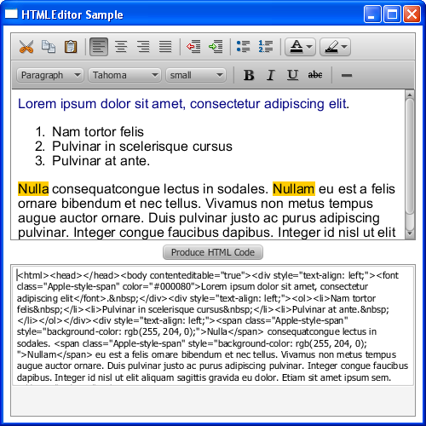
Description of "Figure 19-6 Obtaining the HTML Content"

类似地，也可以获得HTML代码比in个保存为文件或者发送到WebView对象，以同步编辑器和绑定的浏览器中的内容。 下面实现了这个任务 Example 19-6 .
Example 19-6 Rendering Edited HTML Content in a Browser
import javafx.application.Application; import javafx.event.ActionEvent; import javafx.event.EventHandler; import javafx.geometry.Insets; import javafx.geometry.Pos; import javafx.scene.Group; import javafx.scene.Scene; import javafx.scene.control.*; import javafx.scene.layout.VBox; import javafx.scene.web.HTMLEditor; import javafx.scene.web.WebEngine;import javafx.scene.web.WebView; import javafx.stage.Stage; public class HTMLEditorSample extends Application { private final String INITIAL_TEXT = "Lorem ipsum dolor sit " + "amet, consectetur adipiscing elit. Nam tortor felis, pulvinar " + "in scelerisque cursus, pulvinar at ante. Nulla consequat" + "congue lectus in sodales. Nullam eu est a felis ornare " + "bibendum et nec tellus. Vivamus non metus tempus augue auctor " + "ornare. Duis pulvinar justo ac purus adipiscing pulvinar. " + "Integer congue faucibus dapibus. Integer id nisl ut elit " + "aliquam sagittis gravida eu dolor. Etiam sit amet ipsum " + "sem."; @Override public void start(Stage stage) { stage.setTitle("HTMLEditor Sample"); stage.setWidth(500); stage.setHeight(500); Scene scene = new Scene(new Group()); VBox root = new VBox(); root.setPadding(new Insets(8, 8, 8, 8)); root.setSpacing(5); root.setAlignment(Pos.BOTTOM_LEFT); final HTMLEditor htmlEditor = new HTMLEditor(); htmlEditor.setPrefHeight(245); htmlEditor.setHtmlText(INITIAL_TEXT); final WebView browser = new WebView(); final WebEngine webEngine = browser.getEngine(); ScrollPane scrollPane = new ScrollPane(); scrollPane.getStyleClass().add("noborder-scroll-pane"); scrollPane.setStyle("-fx-background-color: white"); scrollPane.setContent(browser); scrollPane.setFitToWidth(true); scrollPane.setPrefHeight(180); Button showHTMLButton = new Button("Load Content in Browser"); root.setAlignment(Pos.CENTER); showHTMLButton.setOnAction(new EventHandler<ActionEvent>() { @Override public void handle(ActionEvent arg0) { webEngine.loadContent(htmlEditor.getHtmlText()); } }); root.getChildren().addAll(htmlEditor, showHTMLButton, scrollPane); scene.setRoot(root); stage.setScene(scene); stage.show(); } public static void main(String[] args) { launch(args); } }
从htmlEditor 组件获得HTML代码加载到WebEngine 对象来指定绑定浏览器的内容。每次用户点击Load Content in Browser按钮，编辑的文本就更新到浏览器中。Figure 19-7 是Example 19-6 运行的效果。

Figure 19-7 Loading Content in a Browser
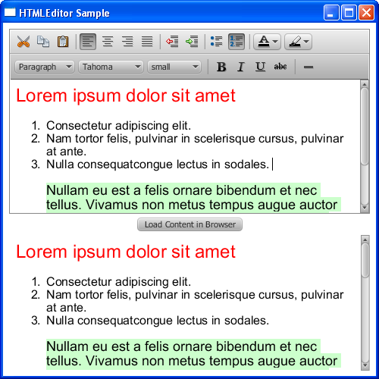
Description of "Figure 19-7 Loading Content in a Browser"

使用Text 组件来添加非编辑文本内容。到Using Text and Text Effects in JavaFX 了解更多Text组件。

